**E-PROJECT REPORT**

**Overview:**

1. Acknowledgements

2. eProject Synopsis

3. eProject Analysis

4. User Guide

5. Developer’s Guide

**1. Acknowledgement.**

We would like to express ours special thanks of gratitude to our main lectures: Mr.Quang Nguyen Van as well as our teaching staff: Mr.Tuan Nguyen and Miss Hanh Hong who gave us the golden opportunity to do this wonderful project on the topic The Cake, which also helped us in doing a lot of Research and we came to know about so many new things we are really thankful to them.  
Secondly We would also like to thank ours parents and friends who helped us a lot in finalizing this project within the limited time frame.

**2. Eproject synopis.**

In today’s day to day life purchasing of products by visiting stores has become a tough job. As a standing in a queue for making the payment of the product has become difficult for customers. To overcome these difficulties, we are coming up with TheCake.

The purpose of our project is to design, publish and maintain a website for our Cake manufactures. TheCake is the Cake website which helps to choose a wide range of products through your desktop or smartphone rather than visiting the outlets. It is developed using HTML, CSS, Javascript which is a basis of almost website, the basic e-commerce functionality in website can be achieved through Javascript. It has been developed to handle dummy procedure for buying to be added and checkout.

HomePage

The home page of a website is the first page that a user perceives upon entering the website url at the browser address area. The entire website depends on how the homepage is designed which forms the platform for viewing other web forms. In short, a home page forms the abstract of the entire website.

Links and Webpages

Through the home page a number of other web pages can be linked. Each link gives an elaborated detail about itself with adequate lists and photos.

**3. Eproject Analysis**

**Home Page (index.html)**

Home page contain a brief description of the entire website.

Homepage consist of:

* Navigation Bar navigate to the sections located on the website.
* A banner slider image at the top of the page
* Our Cakes Section: Introduce the various products TheCake provide
* Wellcome to The Cake: A brief description about TheCake for users
* Banner CallToAction: Encourage customers to view the products on TheCake have.
* New Product: A list of new product.
* Top Sale: A list of best selling product in TheCake.
* Our Story: A brief description about mission, vision, what we are doing
* Banner CallToAction: Encourage customers to view the products on TheCake have.
* Blog: A list of blog about cake, recipes….
* OurTeam: Introduce TheCake team
* Contact us: Form contact
* Testimonials: A list of testimonials of TheCake.
* Our Partner: A list of partner are working with TheCake
* Footer: Basic information of TheCake and QuickLink navigation to go to subpages.
* Movetotop: Back to top of site.

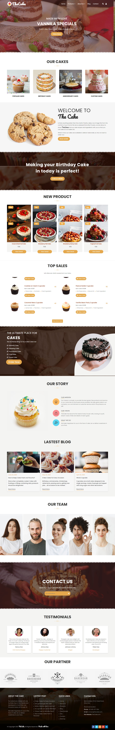

**Products:**

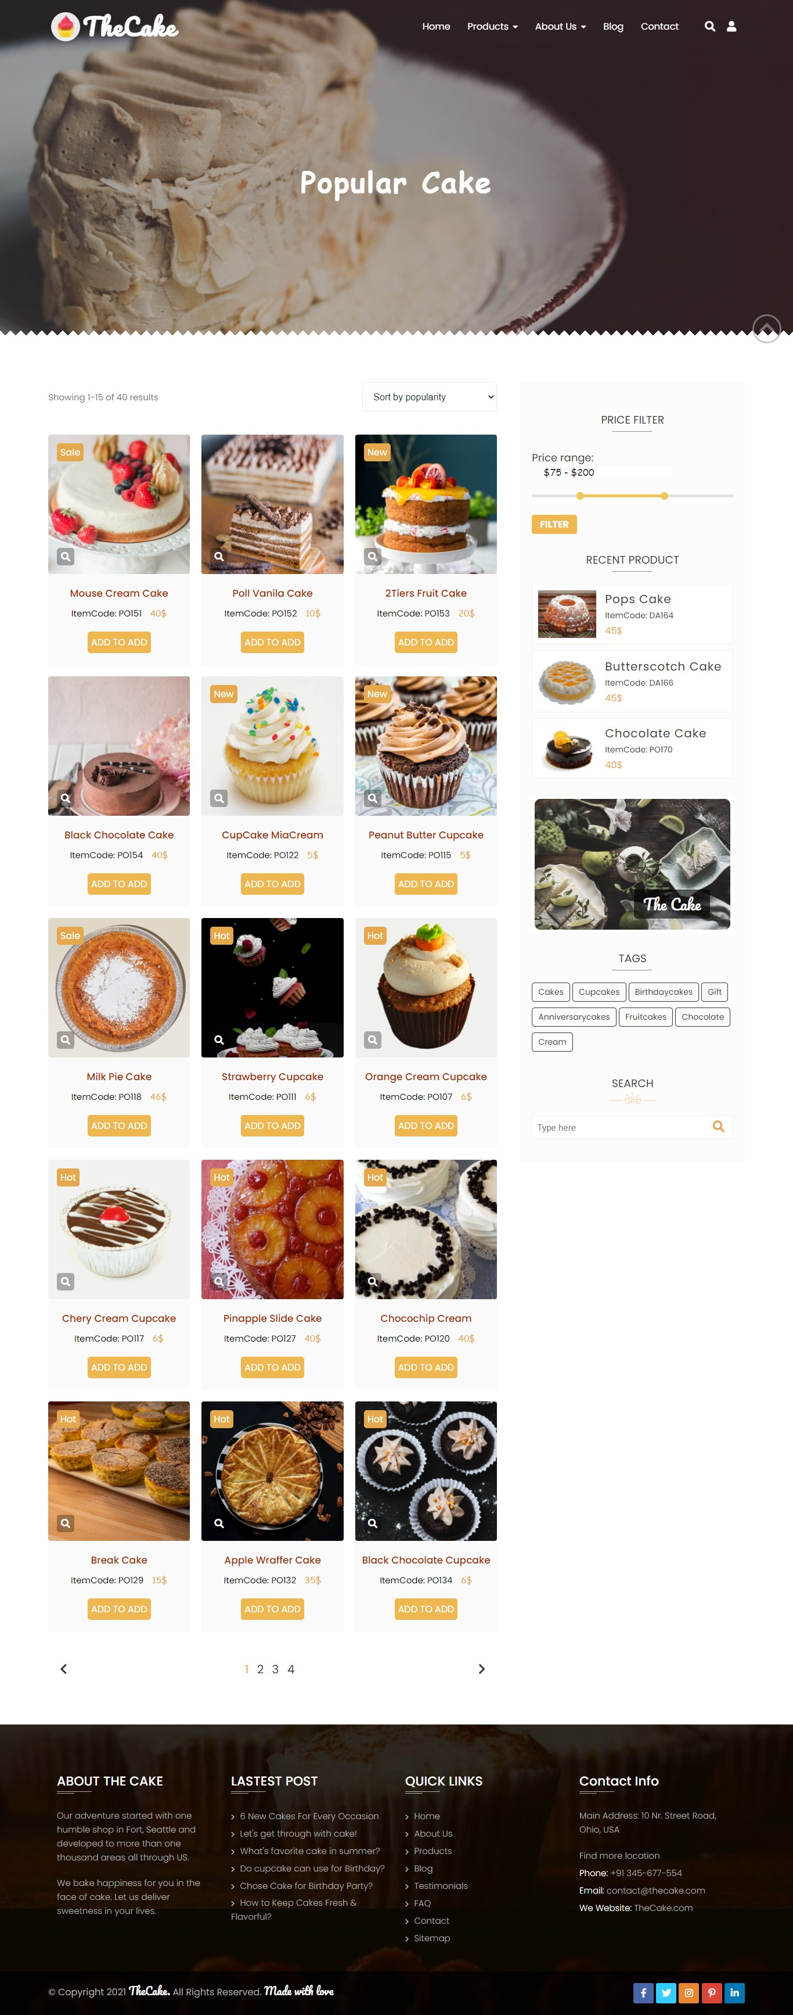

Products entry is divided into 3 subpages:

All popular cakes: Cupcake, sweetcake, fruit cakes, …

Events cakes: BirthdayCake & AnniversaryCake

Desgin Your Cake: We offer services to custom cake.

* PopularCake, BirthdayCake, AnniversaryCake consist of:
  + Main Content: A list of products.

In each product: Zoom function image, ItemCode, Price, Add to Cart button.

Click to name product -> Link to details about this product.

* + - Detail product: A detail information of product: Price, Size, Name, Description, Select Quanity, Shipping information, Image List, Review, Additional Information, Checkout button.
    - In the bottom: Slider Related Products: Zoom function.

Add to Cart button -> Show a brief description popup about the product.

* + Aside Content: Filter Price,Recent Product, Tags, Search, Banner.
  + Bottom Site: Panigation.
* Design Your Cake: A Price Custom Option, Custom Form Order, A list of works.

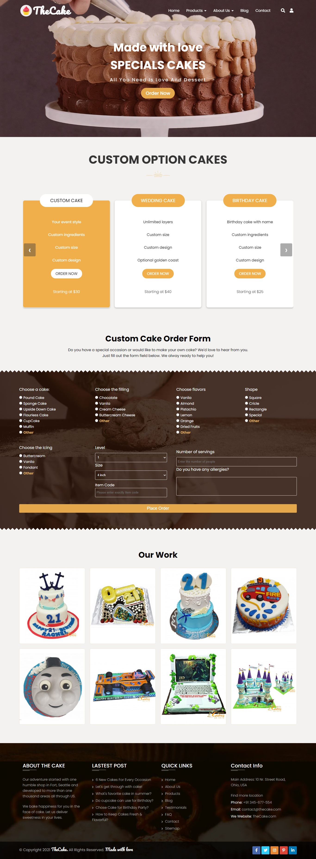

**About Us:**

Divide the page into three sections vertically. Provide the foundation, mission and vision on these sections.

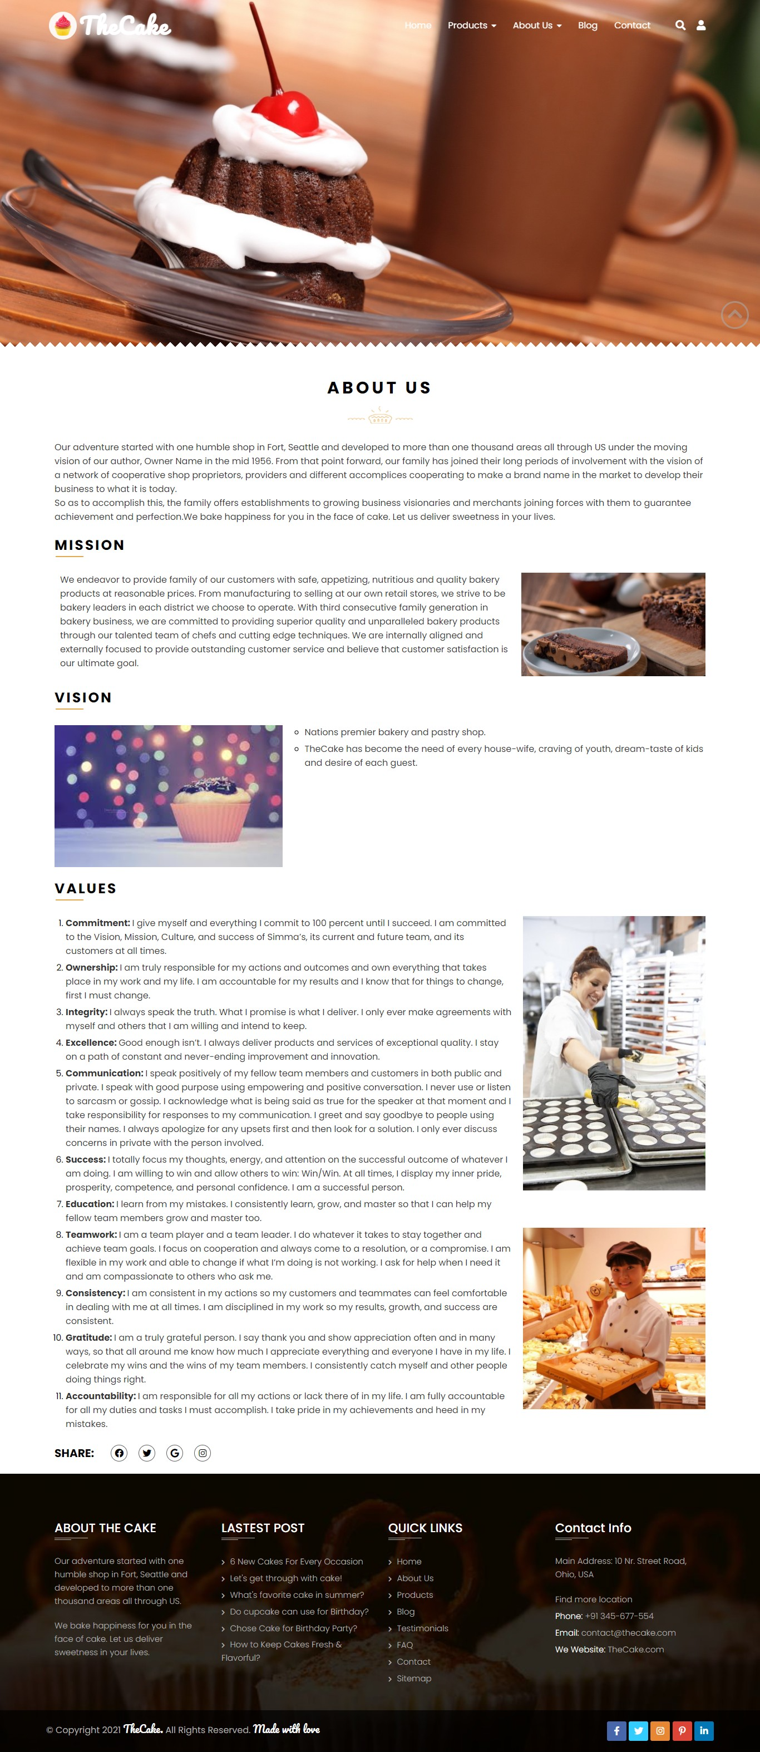

**Blog:**

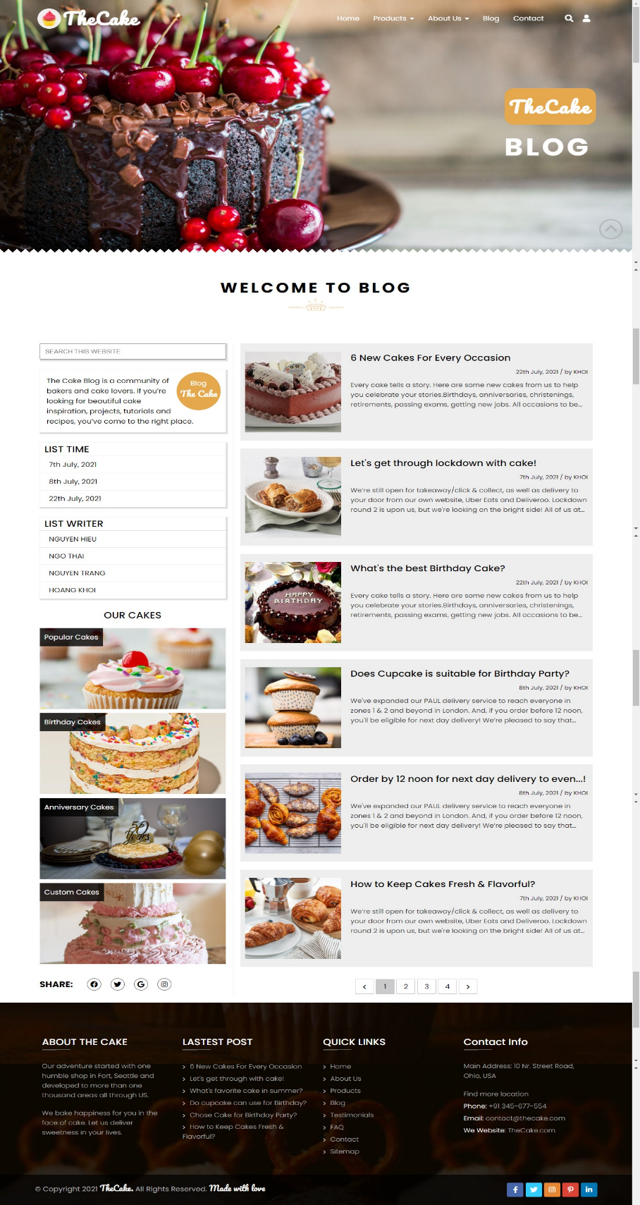

Blog divide into 2 section:

* Aside Content:Blog Description, Search, List our cakes
* Main Content: A list of blogs
  + When click into heading blog -> Link to blog details site
  + Blog details site

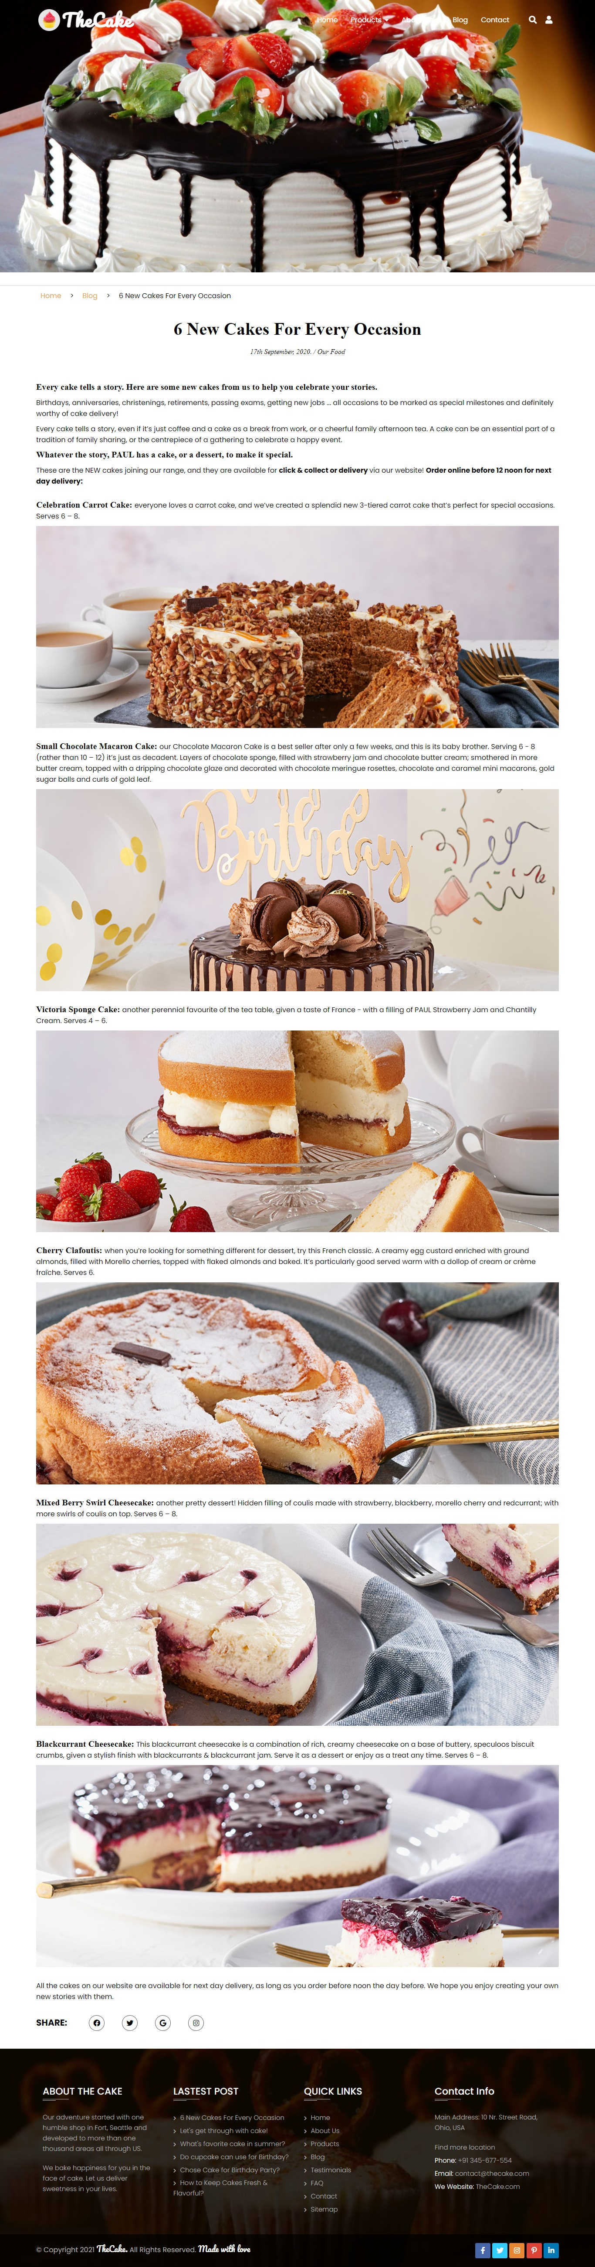

* Panigation

**Contact Us:**

Contact us have the Address of the Company and the mail address which when clicked will invoke the local mail client from where they can send an email. Address of the Company should be displayed using GeoLocation API (eg. GoogleMaps)

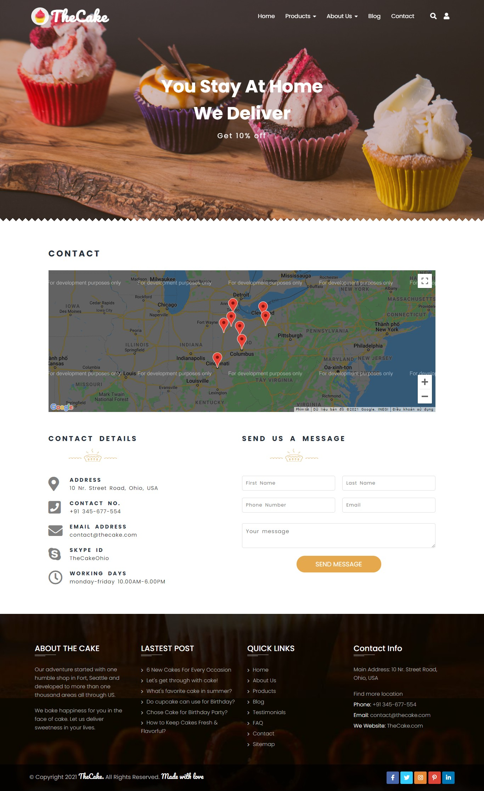

**Term:**

These terms and conditions serve as the contract between the customer and The Cake. By paying this invoice, the customer is agreeing to these terms and conditions. Terms and conditions are subject to change without notice.

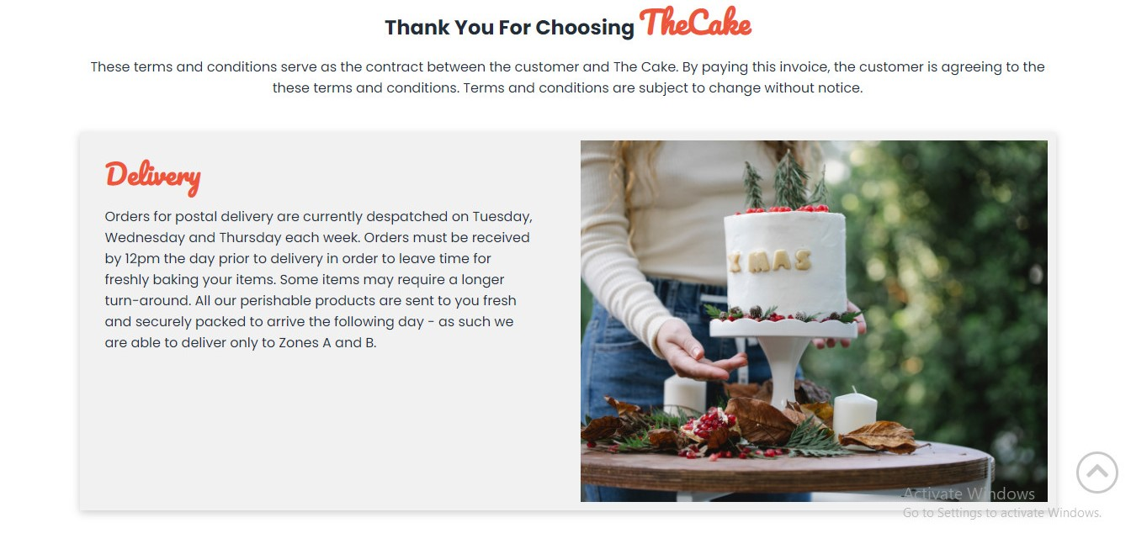

**FAQ:**

Provide a list customer frequently questions about TheCake

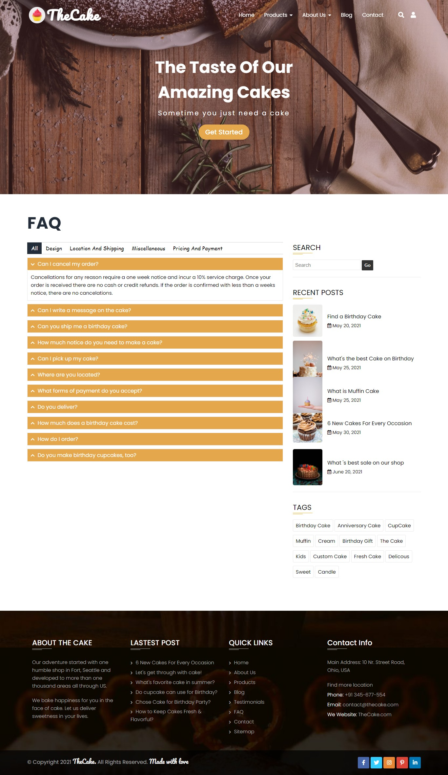

**Testimonials:** A list of testimonials of TheCake.

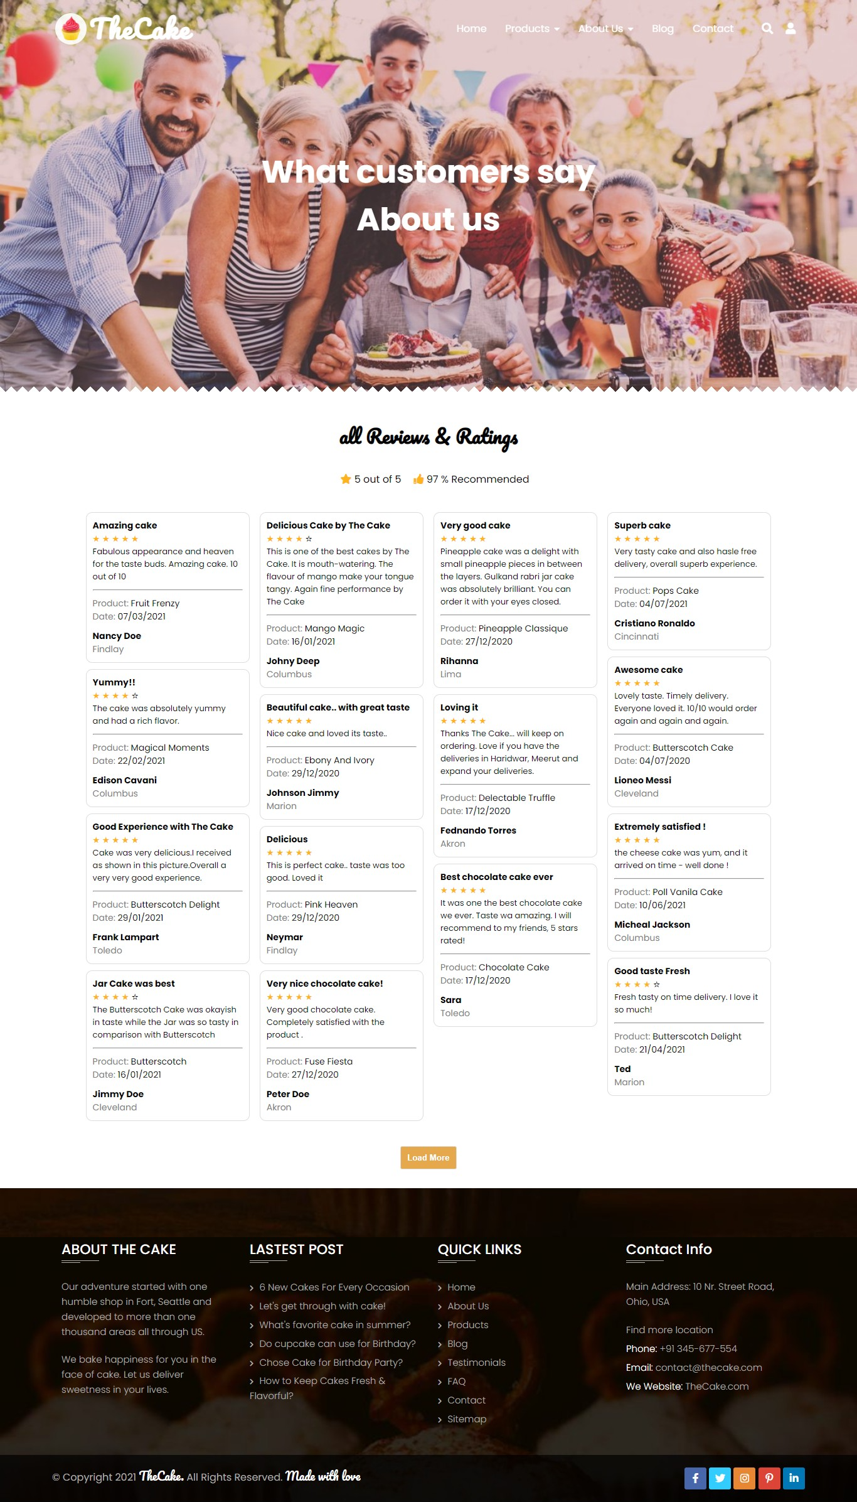

* When click on button load more -> link to another testimonials ratting site with filter for each star review.

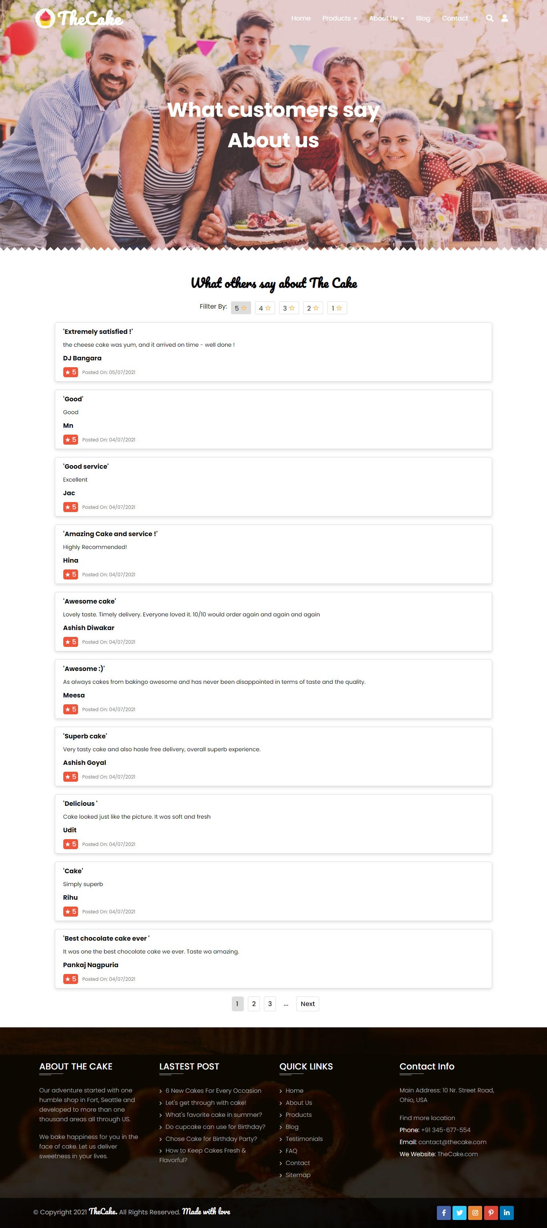

**Team:** Introduce TheCake team

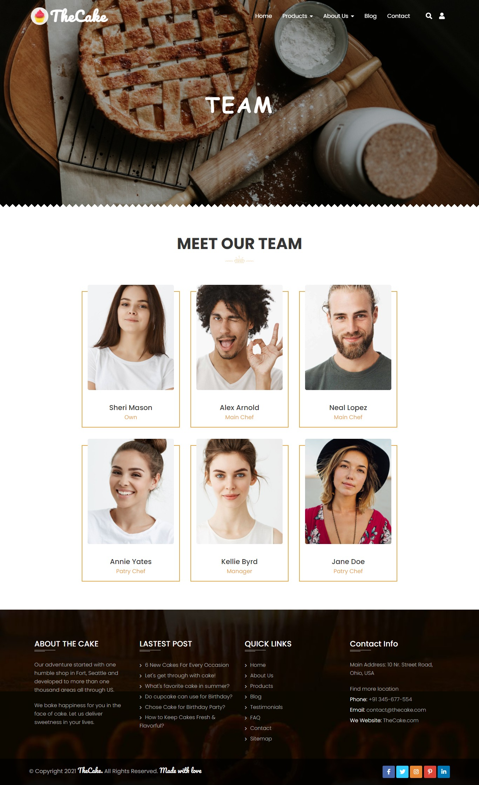

**Detail Product:**

Details Product: This site contains information about this product, price, detail ingredients, chose size, chose shape, select quanity, review, gallery product image. At the bottom, slider related product.

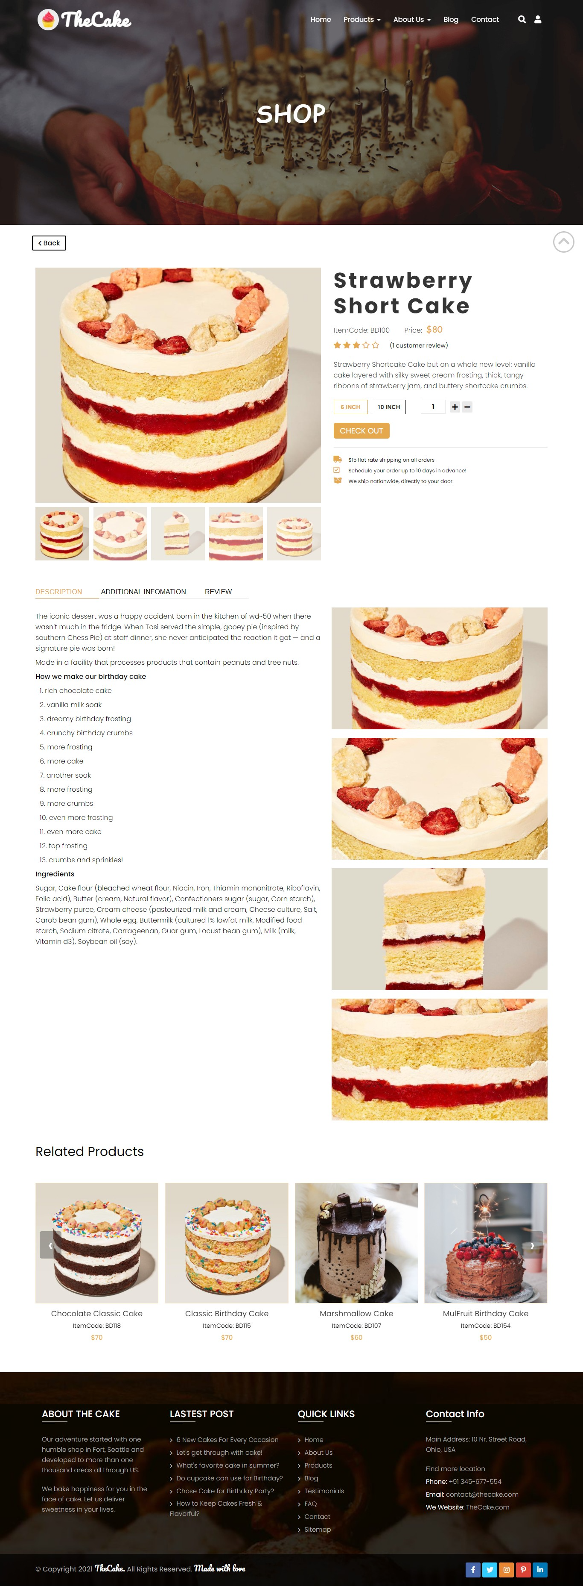

**CheckOut Site:**

Customer Information: Address, Name, Mail, …

Detail order: Name Product, Quanity, Price, Total

Payment Method: Credit Card, Paypal, …

Place Order

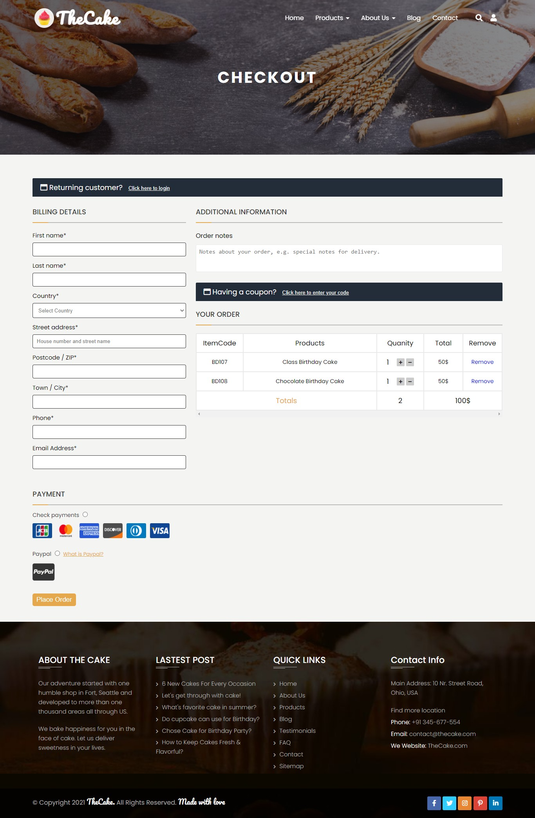

**Login:**

Login and Register site

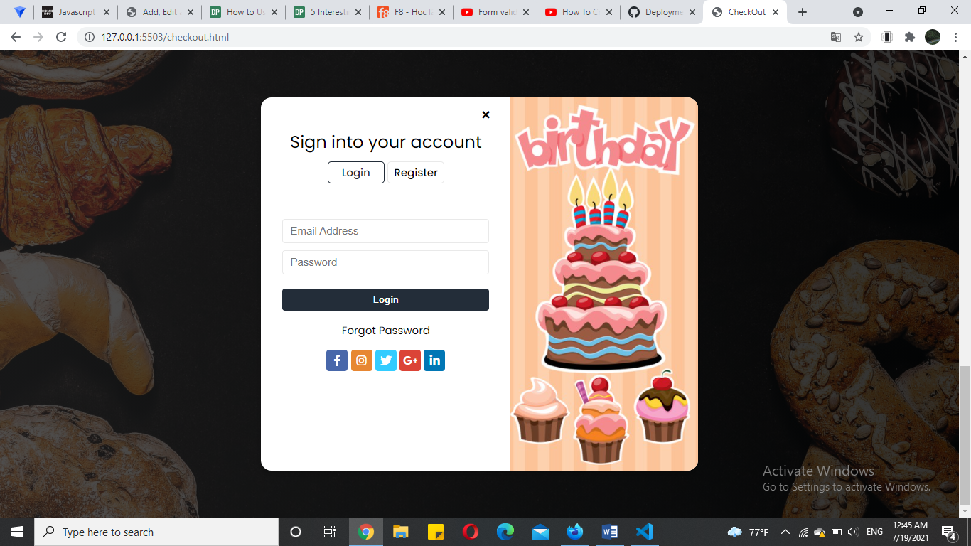

Dummy procedure for buying to be added**:**

When click add to cart -> show a popup which customer can view image product, name, price, itemcode and chose size -> Checkout

Thêm ảnh

**4. User guide**

**4.1 Site map.**

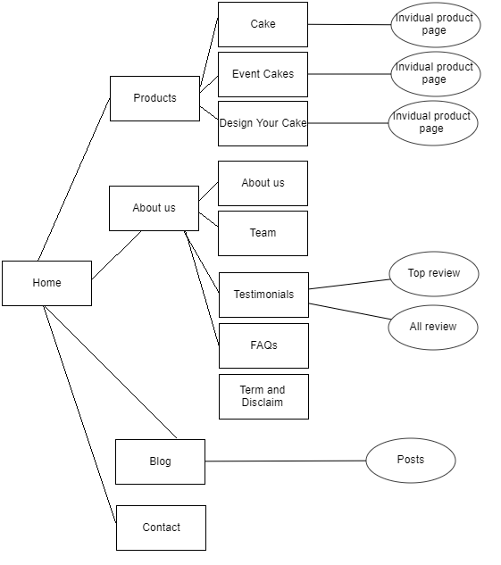

**4.2 User’s guide.**

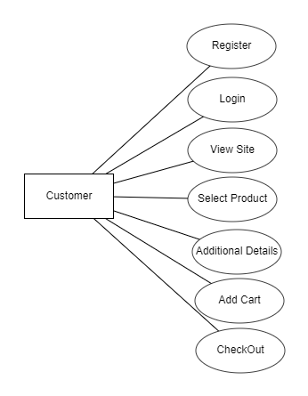

**4.2.1. Register and login**

In the homepage, you can register as a new member and login:

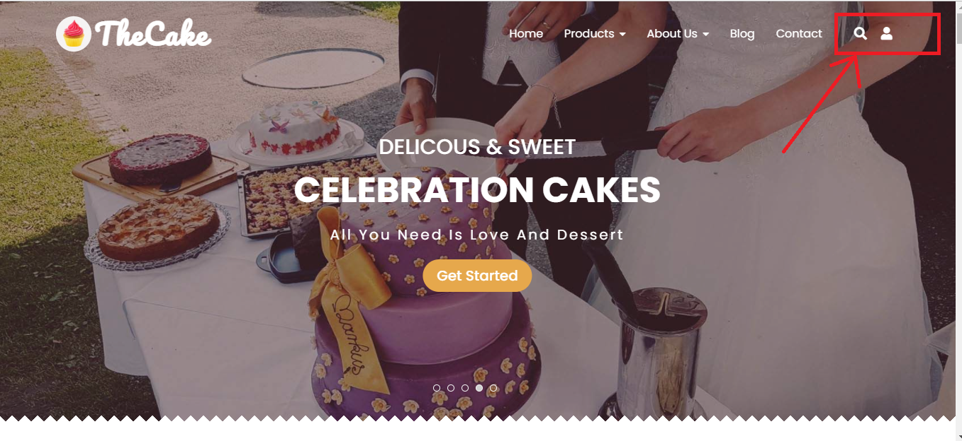

The interface like the figures below:

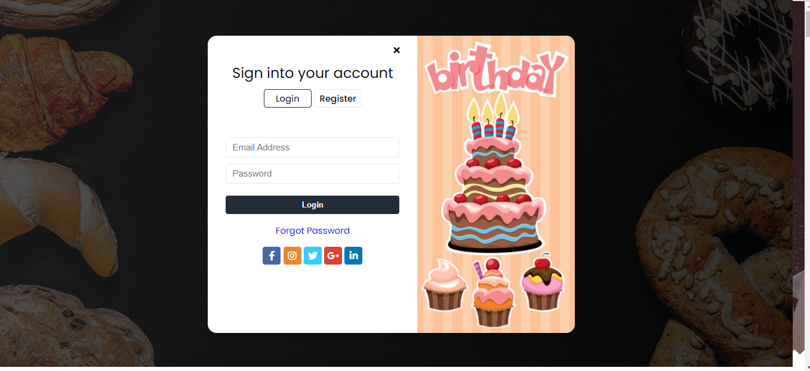

**4.2.2. Website link**

At the homepage, we create quick links to the cake event pages like figures:

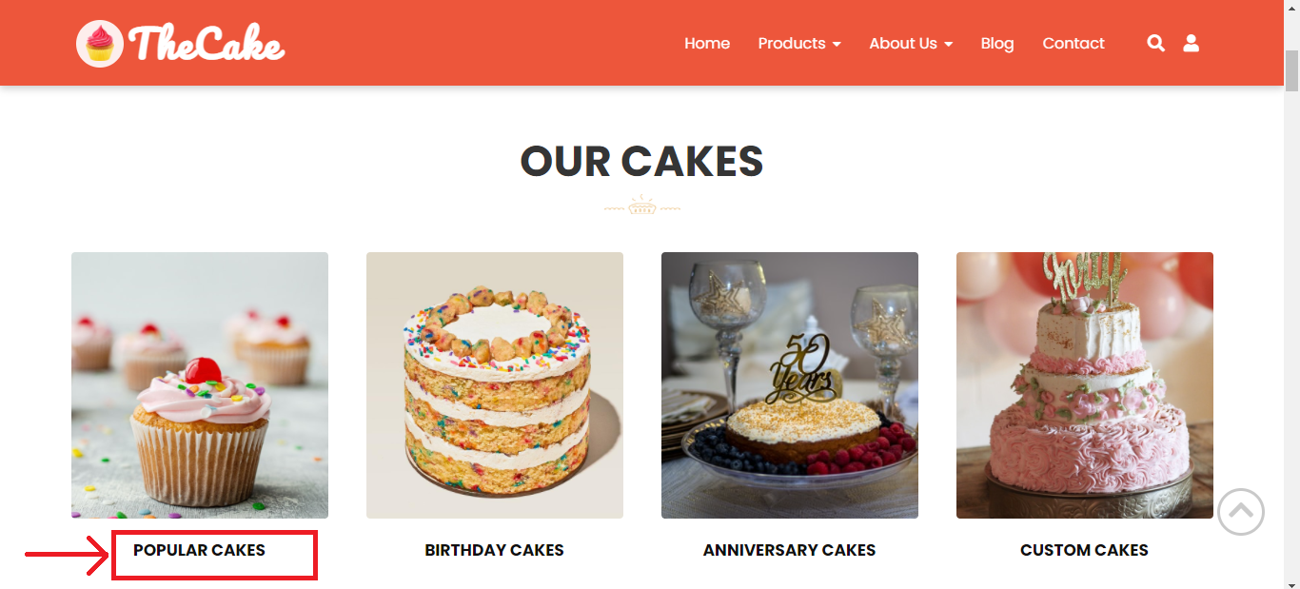

You can easily access the invidual event cakes page and choose the right cake you need.

Especially, we create the “new product” section to launches new products and the “top sales” section to present our best - selling products at the moment. Shown in the figure below:

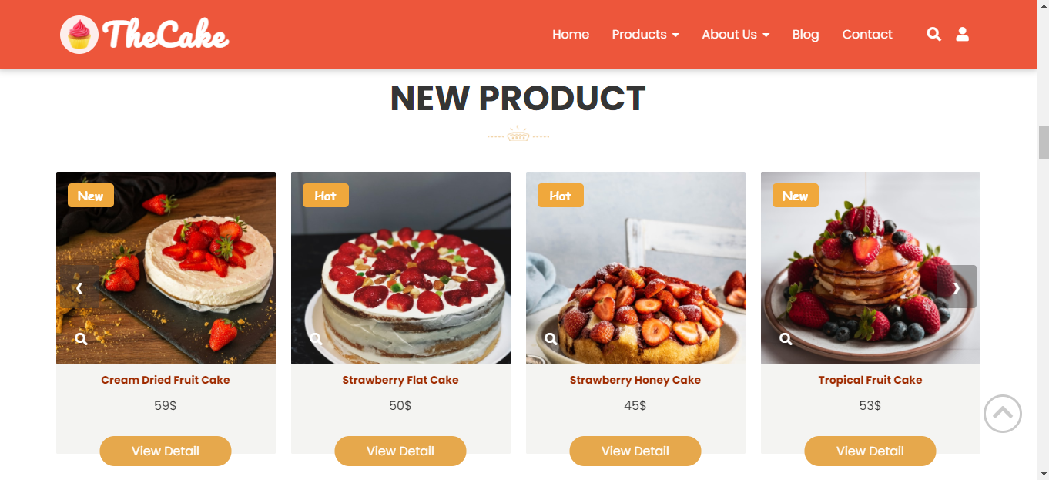

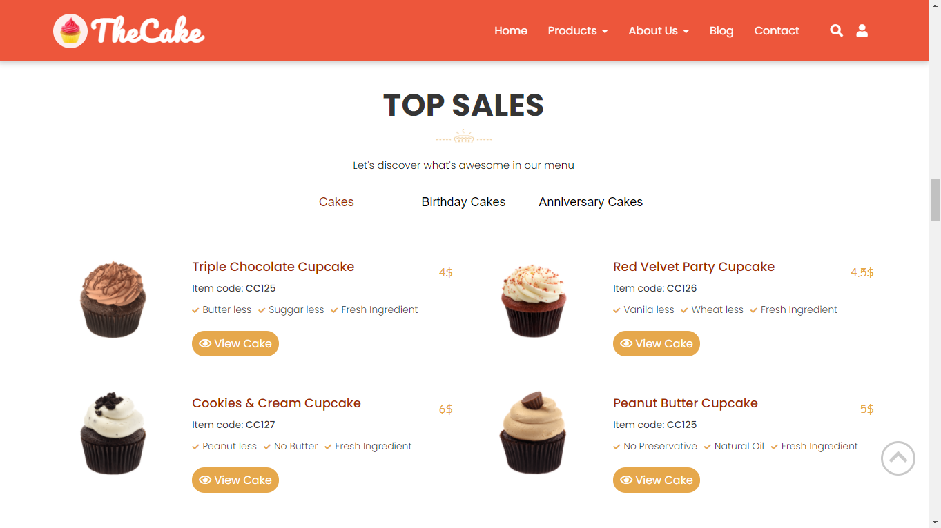

**4.3 Shopping guide.**

From the homepage, you can click “view detail” button on hot products section and “view cake” button on top sales section to make a purchase, or you can access the invidual product page on the navigation bar.

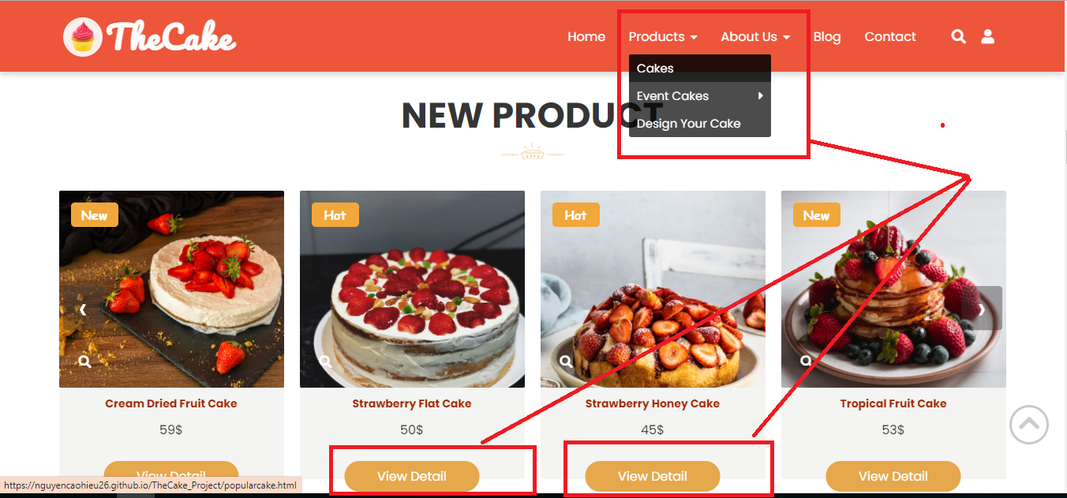

The invidual product page will apprear like this:

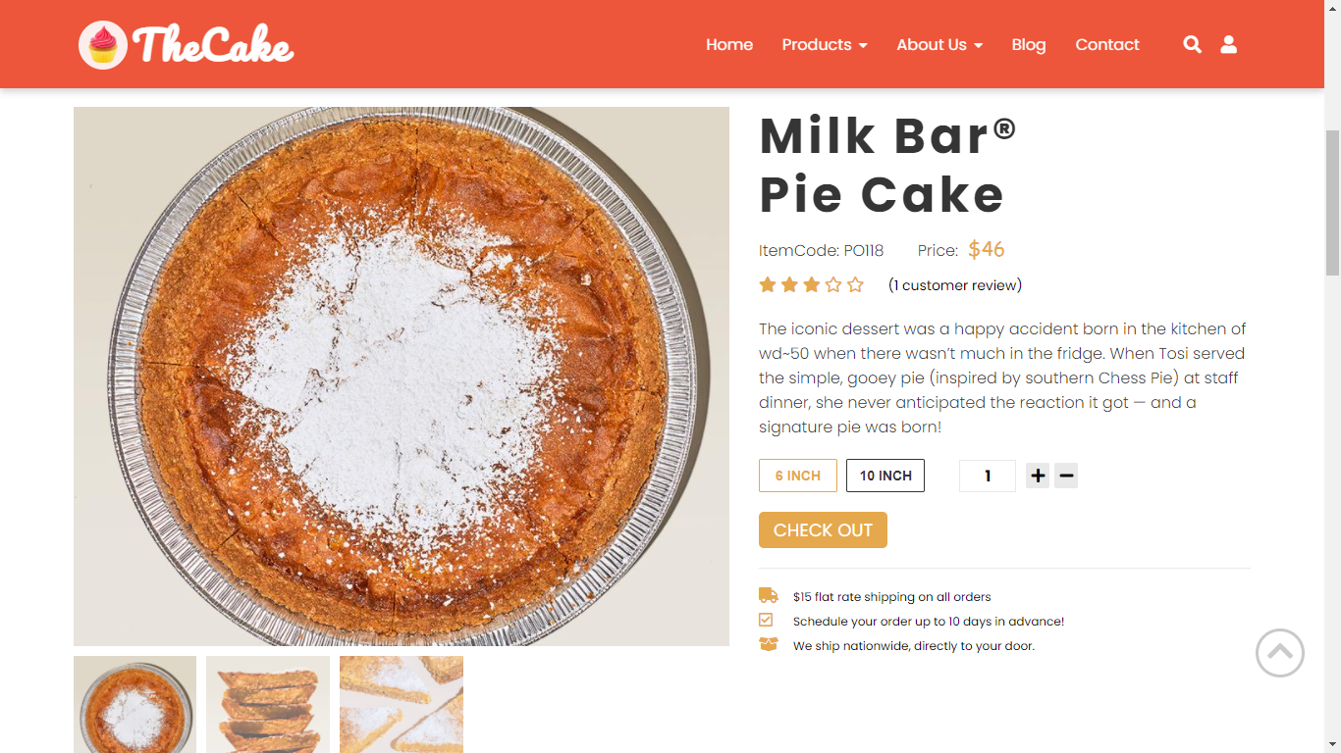

Then, click on “check out” button to processed order, you need fill all information to complete the order. The billing details like figures below:

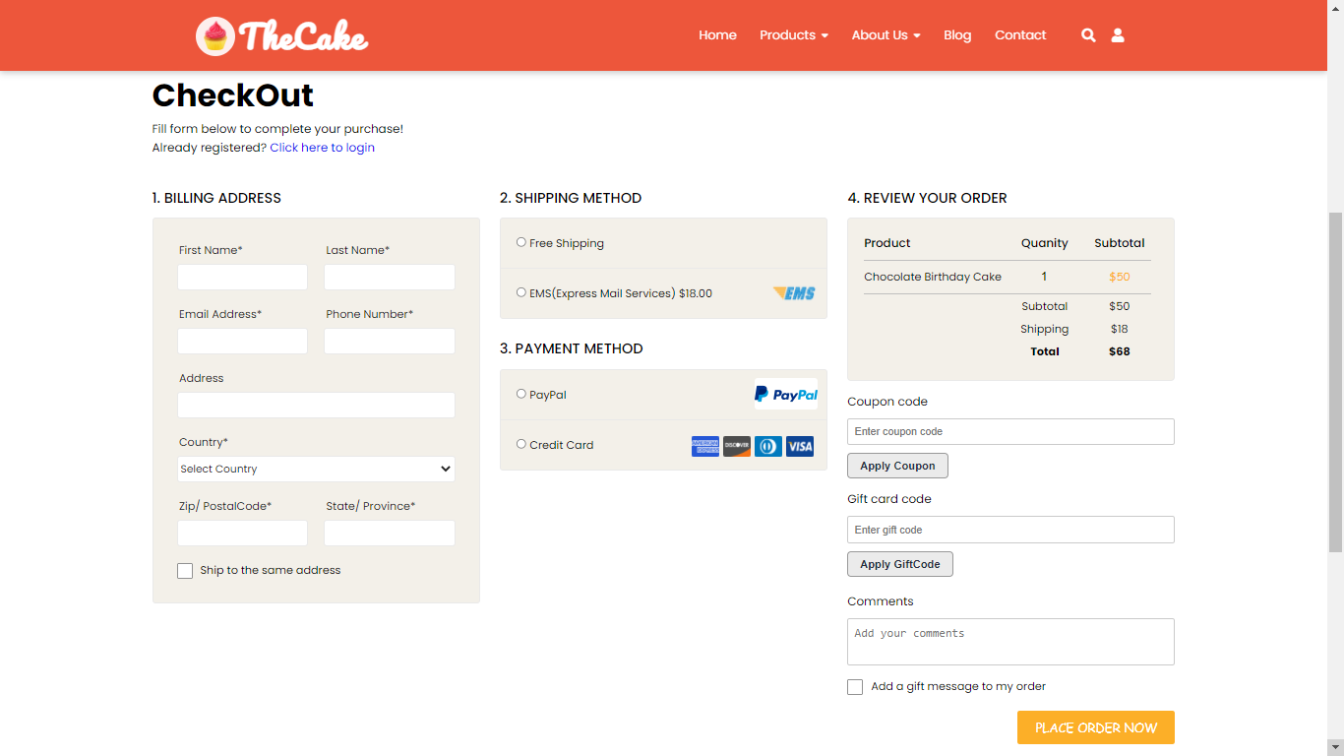

**5. Developer guides:**

We use html5, css3 (with grid and flex to create layout), Javascript and Jquery to build the website. No plugins are used, so if the developer want to maintain the website, please follow these instructions:

**5.1. Download Source code.**

- Go to <https://github.com/nguyencaohieu26/TheCake_Project>

- Click on button: “Code”

- Click copy

- On cmd, choose the folder to save project then type command:

git clone <https://github.com/nguyencaohieu26/TheCake_Project.git>

**5.2. How to maintain html code**

- We separate source code into 21 pages, each page namely: [Name of page].html. See the illustration below:

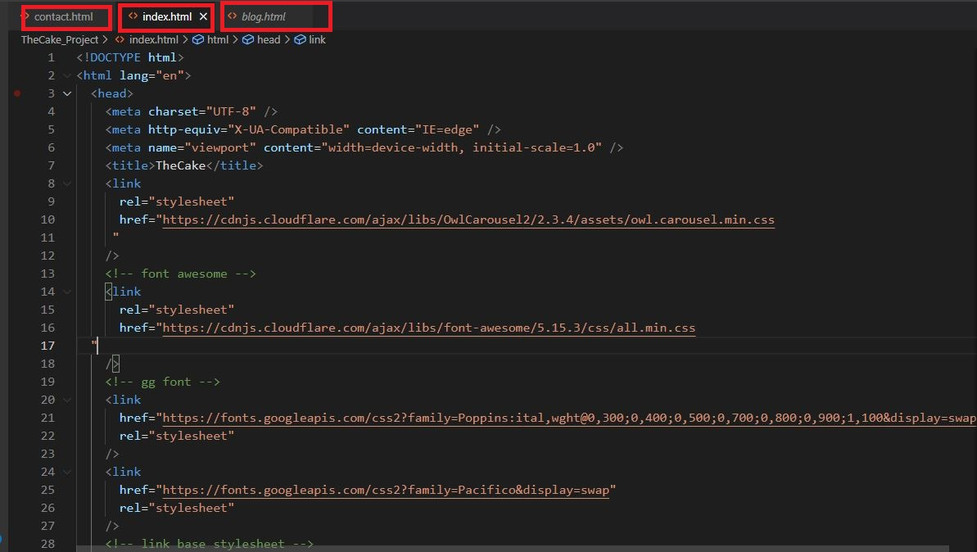

- In every page we comment every section to define each part. Example:

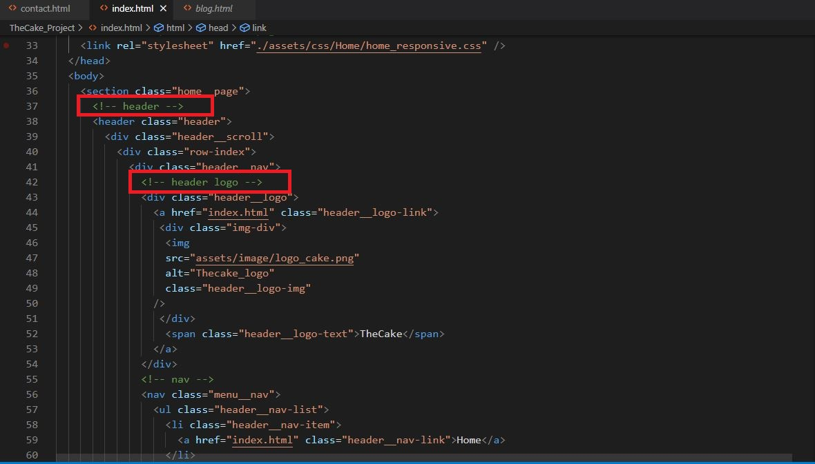

- Find the part name and change source code needed for maintenance.

**5.3. How to maintain Cascading Style Sheets and responsive**

- We namely the part of Cascading Style Sheets source code as: [Name of page_page_css], and each page, we namely each section source code as: [Name of section] See the illustration below:

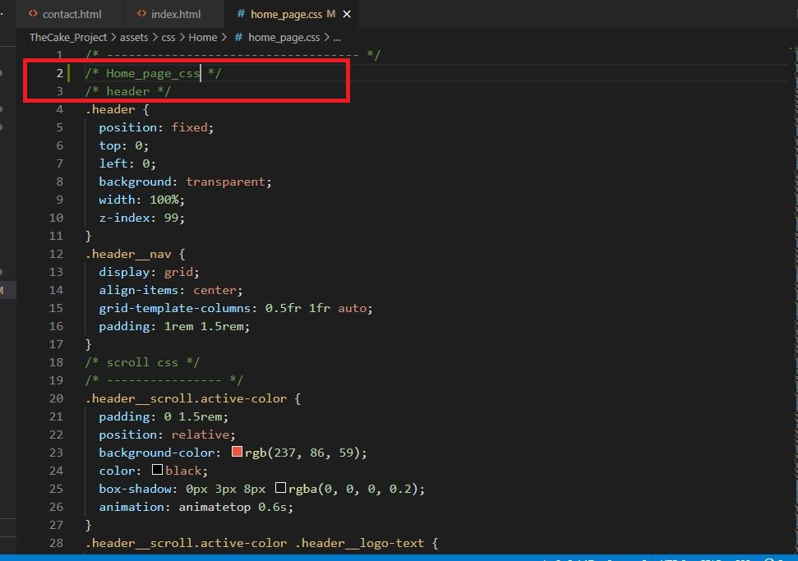

- Find the part name and change source code needed for maintenance.

**5.4. How to maintain javascript code:**

- We namely the part of Javascript source code as: [Name of page_page_javascript], and each page, we namely each section source code as: [Name of section] See the illustration below:

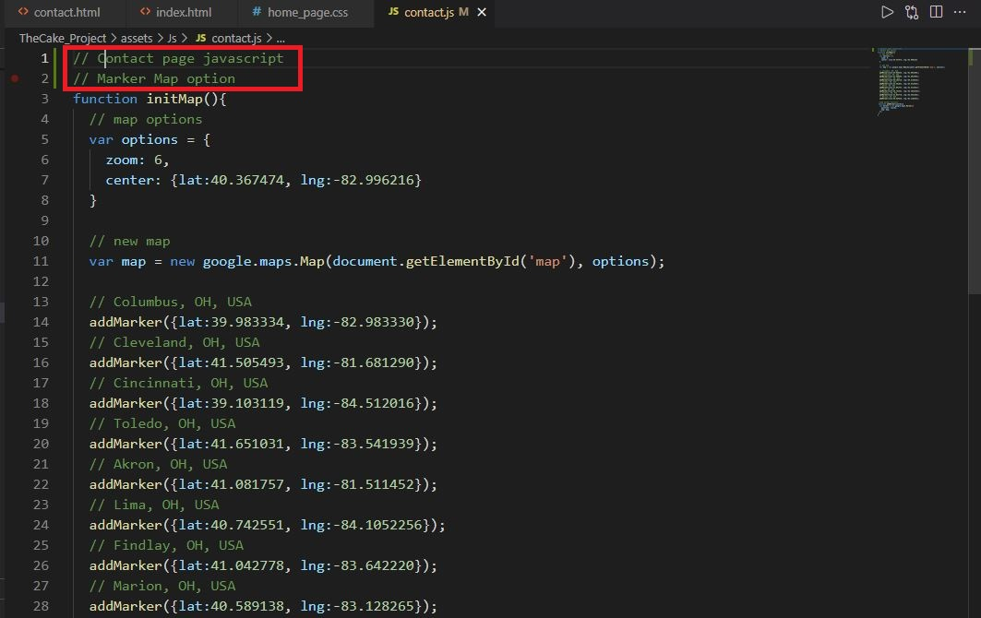

- Find the part name and change source code needed for maintenance.

**5.5. Extension**

- Install “live server” in Visual studio code for run live website (no need to reload website when every time update source code) follow step by step below:

+ Click on Extensions button on Visual Studio Code.

+ Type “live server” on search bar.

+ Click on “Install” and wait to setup complete.

+ Restart Visual Studio code.

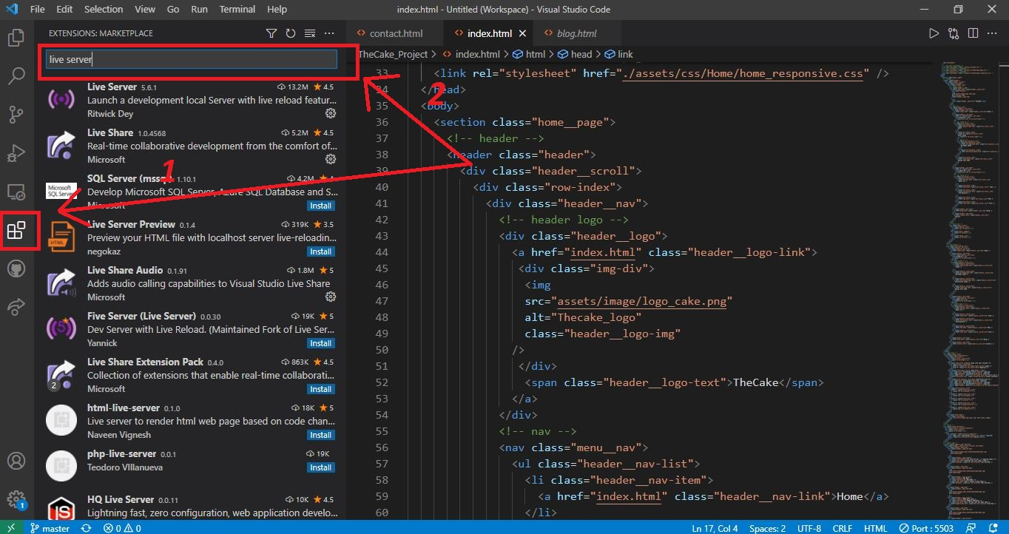

**5.6. Browser support**

- Support chrome browser version 57.0 and above.

- Support firefox browser version 52.0 and above.

- Support IE browser version 11.0 and above.